Contents

1.Pre-requisites: 2

2. Creating & Configuring Gradle Project in Eclipse: 2

2.1 Install Gradle Plugin onto Eclipse: 2

2.1.2 Create Folder Path: 3

3. How to run Automation Jar file: 3

4. For Printing Test Report: 4

5. Jenkins Configuration: 4

5.1 How to configure run Jenkins war file: 4

6. Browser and Web Driver Information: 7

# 1.Pre-requisites:

#### 1.1 Pre–requistes to run TestSuite:

* Java Version: 1.8
* IDE : Eclipse IDE (Latest Version).
* Browser : We need to use relevant driver.exe files (for example : browsername.exe) for Chrome and IE Browers.(ChromeBrower file attached in GitHub)
* Install Gradle and configure in Environment Variables.

## 2. Creating & Configuring Gradle Project in Eclipse:

## 2.1 Install Gradle Plugin onto Eclipse:

* In Eclipse IDE – navigate to Help -> Eclipse Market Place, search for “**Build ship Gradle Integration**” and install into the Eclipse.

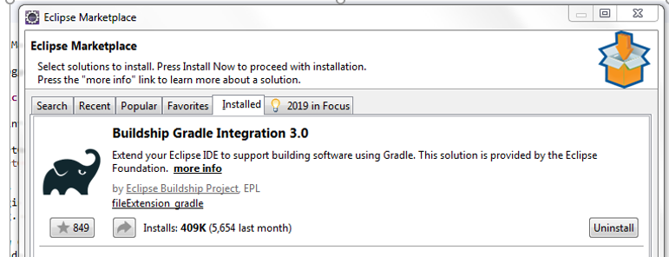

* To Create a Gradle Project, File-> New -> Others(If Gradle is not listed)-> Select Gradle Project.
* Click Next
* Give your project name (Like: Canvas Gradle) and workspace where you want to save your file.
* Don’t override settings checkbox. Should be disabled and Click Next
* Click Finish.
* Project will be created successfully.
* After successful project creation configure build.gradle file. I have attached sample build.gradle file in Github.
* After successful creation of build.gradle file, right click the Project->Gradle -> Refresh Gradle Project – It will automatically sync all the libraries into the project.
* Import all the Java files from Github (Repositary : raremoon-testing, Folder : Selenium -> Gradle_Project) to eclipse “/src/main/java”.

### 2.1.2 Create Folder Path:

* **Kindly create a folder in D drive as mentioned “D:\AngularAutomation” and import all the files from GitHub onto that folder. Files details attached below**.

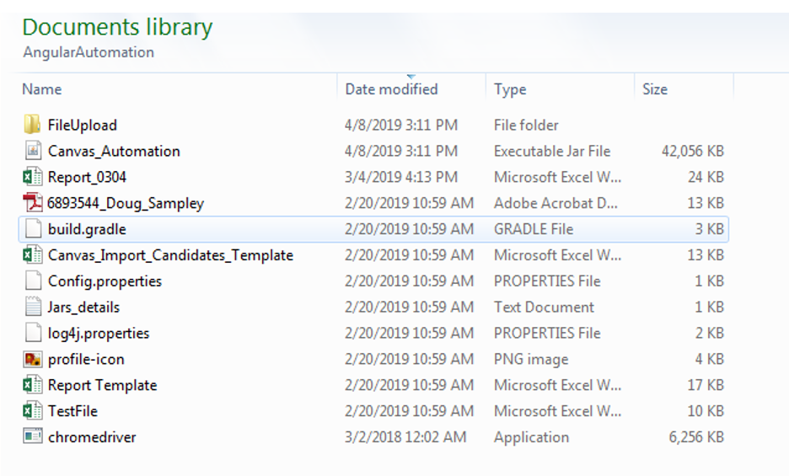

* **Since I have configured Auto-IT script to upload files from the defined location.**

# 3. How to run Automation Jar file:

* Navigate to the folder where you have placed all the files (i.e . **D:\AngularAutomation)**
* You can directly run “Canvas_Automation.Jar” file by double clicking the file.
* We can run from Command Prompt :
* Traverse to Jar located Path, use command **“java -jar Canvas_Automation.jar”.**

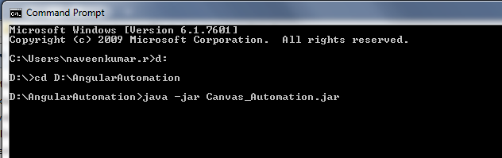

## 4. For Printing Test Report:

* We are using Excel file for print test report:
* Once the application staring to run, in the Extracted Jar location path, you can see “Report.xls” Where you will find all details

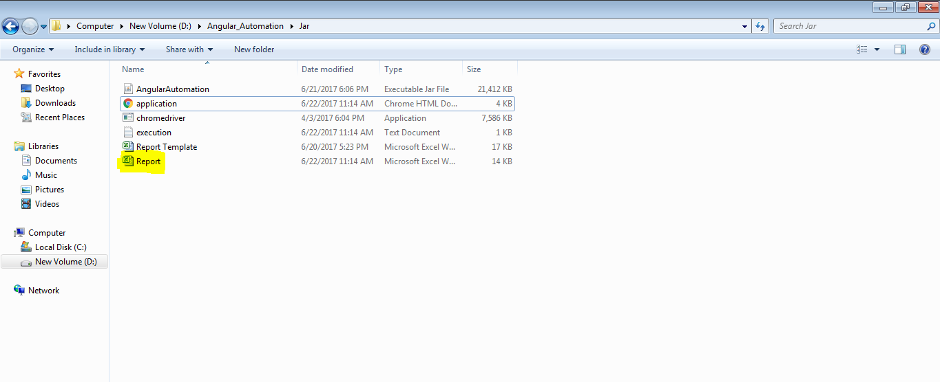

## 5. Jenkins Configuration:

* Download latest version Jenkins war file from <https://jenkins.io/download/>.

## 5.1 How to configure run Jenkins war file:

* Navigate to path where you have placed the jar file and give below command.

“java -jar jenkins.war --httpPort=9090” in command prompt.

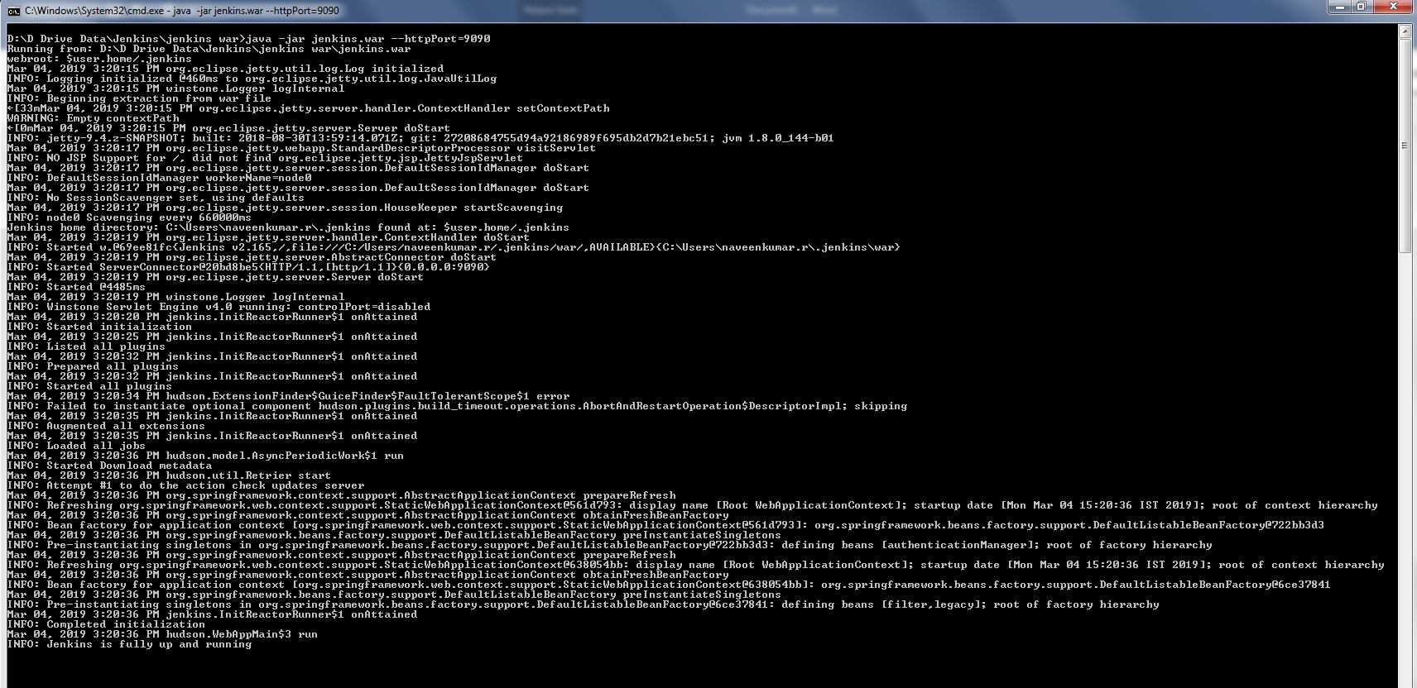

* To Create a new task for Jenkins, click on “New Item” then enter an item name that is suitable for your project and select Freestyle project. Now click Ok.
* Select the GitHub project checkbox and set the Project URL to point to your GitHub Repository.

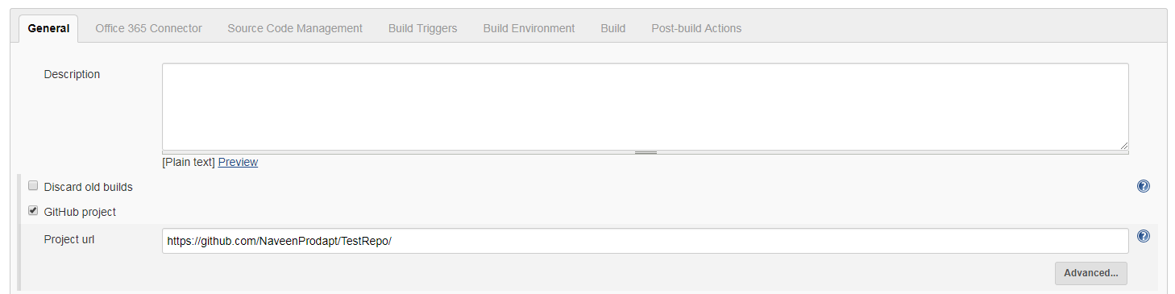

* Under Source Code Management tab, select Git and then set the Repository URL to point to your GitHub Repository.

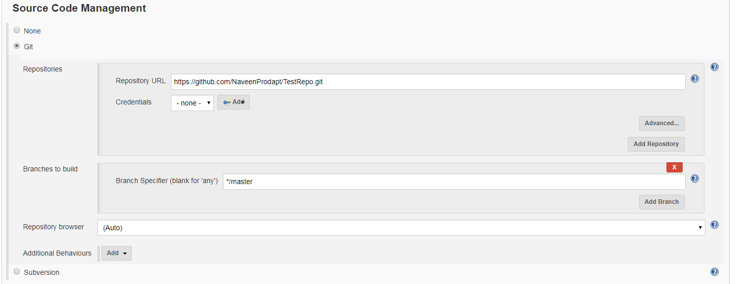

* On the build trigger section, Select Checkbox – Build Periodically.

0 8 * * * : Will run automation jar every day at 8 AM.

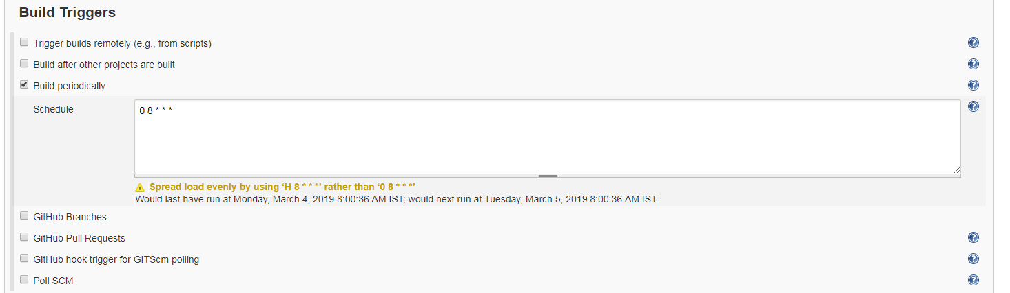

* On the Build Section, Select “Execute Windows Batch Command”.

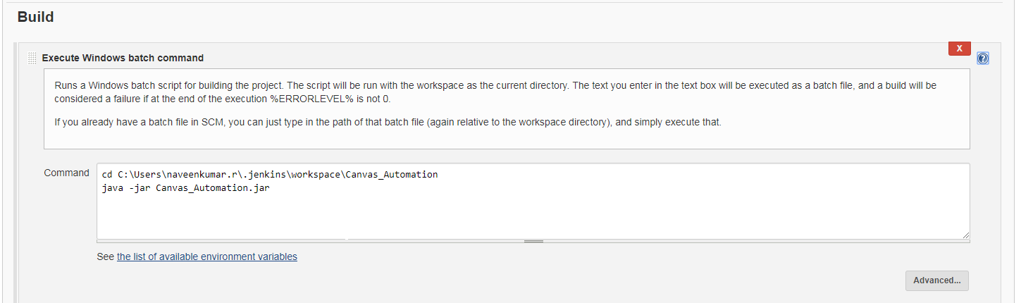

* In the Post Build Action, Select Editable Mail Notification section, from which you can see mail configuration.

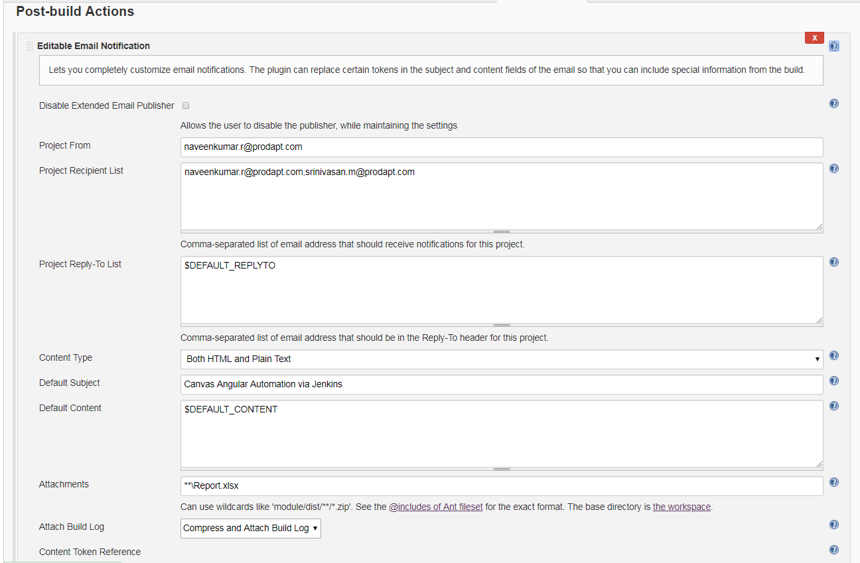

**Note :** To enable mail notification, navigate to Manage Jenkins -> Configure System-> Email Notification

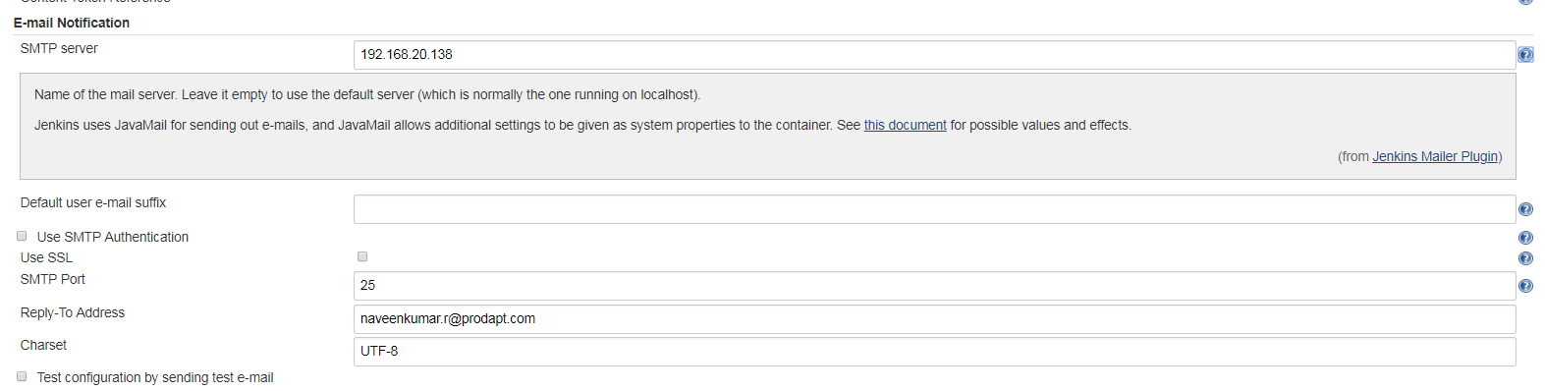



## 6. Browser and Web Driver Information:

* Chrome Browser – Version 70.0
* chromedriver – Version 2.36
* Download Link for chromedriver: <https://chromedriver.storage.googleapis.com/2.36/chromedriver_win32.zip>